A **complete binary tree** is a binary tree in which every level, except possibly the last, is completely filled, and all nodes are as far left as possible.

Design an algorithm to insert a new node to a complete binary tree keeping it complete after the insertion.

Implement the CBTInserter class:

* CBTInserter(TreeNode root) Initializes the data structure with the root of the complete binary tree.
* int insert(int v) Inserts a TreeNode into the tree with value Node.val == val so that the tree remains complete, and returns the value of the parent of the inserted TreeNode.
* TreeNode get_root() Returns the root node of the tree.

**Example 1:**

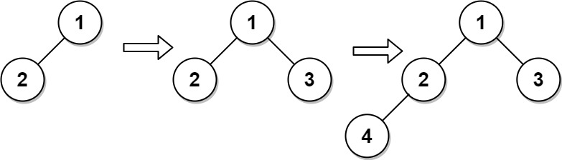

Input  
["CBTInserter", "insert", "insert", "get_root"]  
[[[1, 2]], [3], [4], []]  
Output  
[null, 1, 2, [1, 2, 3, 4]]  
  
Explanation  
CBTInserter cBTInserter = new CBTInserter([1, 2]);  
cBTInserter.insert(3); // return 1  
cBTInserter.insert(4); // return 2  
cBTInserter.get_root(); // return [1, 2, 3, 4]

**Constraints:**

* The number of nodes in the tree will be in the range [1, 1000].
* 0 <= Node.val <= 5000
* root is a complete binary tree.
* 0 <= val <= 5000
* At most 104 calls will be made to insert and get_root.